**Exp. No : 3**

**Map Reduce program to process Weather dataset**

1. Download Weather dataset.

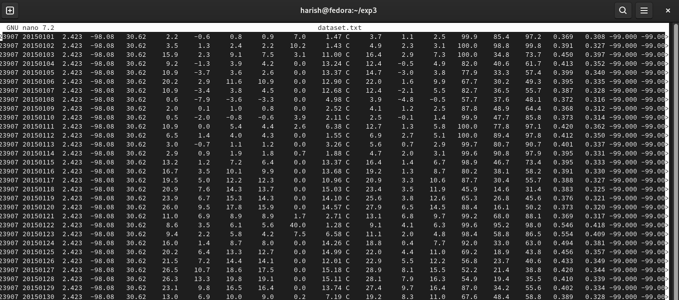

1. Create mapper.py program

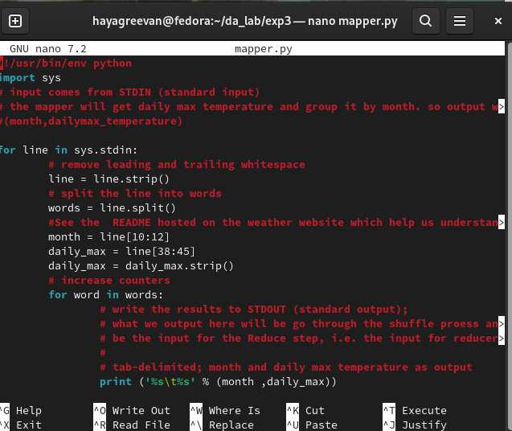

1. Create reducer.py

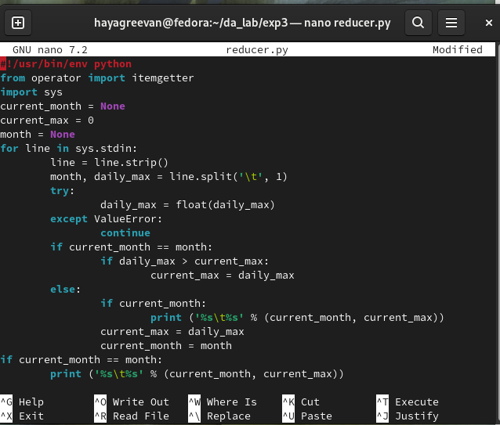

1. Start Hadoop services.

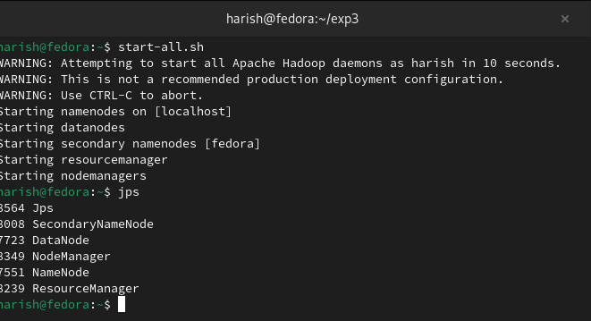

1. Upload Weather dataset into HDFS Storage.

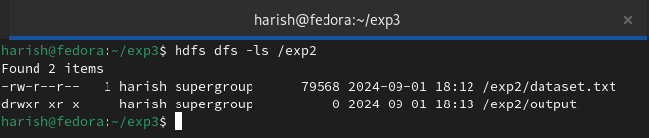

1. Run the Map reduce program using Hadoop Streaming.

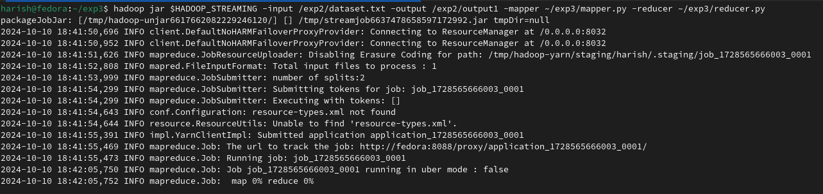

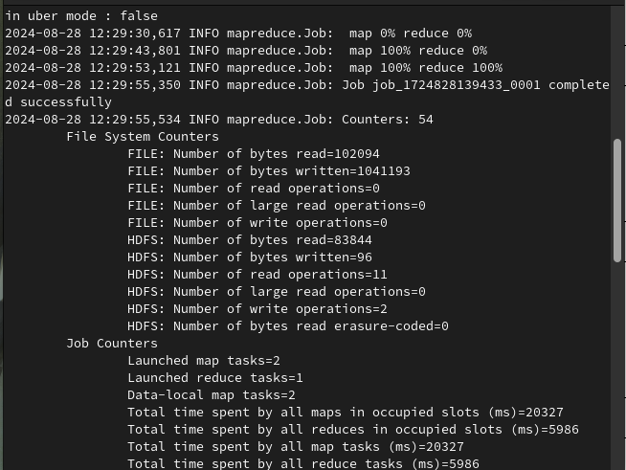

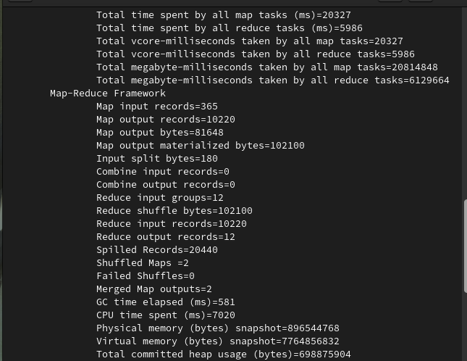

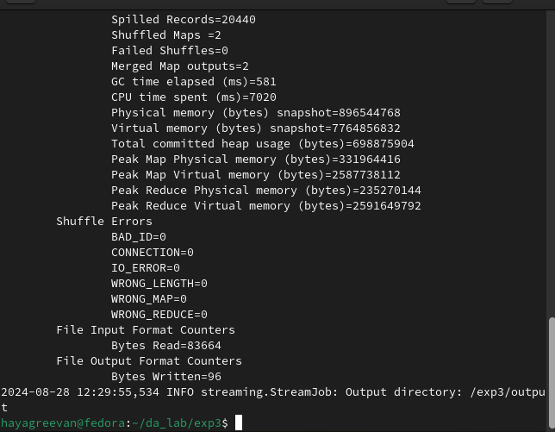

**Output :**

